HOLY CROSS CONVENT SENIOR SECONDARY SCHOOL,AMBIKAPUR

CLASS - IV
SUBJECT - ENGLISH GRAMMAR

Note: Students are instructed to write the following notes in their English grammar book with pencil.
Students not having the book can practice it in their English practice copy.

- ABSTRACT NOUNS-

Abstract nouns- The word abstract means having no material body.
Abstract things have no material bodies. They cannot be seen or touched.
Example-
- Youth is rash but childhood is innocent.
- Chillies have a very hot taste.
- Beauty needs no ornaments.
- Poverty is a big curse.

In these sentences-
- Youth and childhood are the names given to states of the body. We cannot touch them.
- Taste is the name of a quality. We cannot touch it.
- Beauty is the name of a quality. We cannot touch it. We can only look at beautiful things.
- Poverty is the name given to a condition/state. We cannot touch it because it has no body, we can only feel it.
So, the word youth, childhood, taste, beauty, poverty are all abstract nouns.
An abstract noun is usually the name of a quality, action, or the state that cannot be seen or touched.

B.FORMATION OF ABSTARCT NOUNS
Abstract nouns can be formed from common nouns, verbs and adjectives.

- FROM COMMON NOUNS
- FROM VERBS
- FROM ADJECTIVES

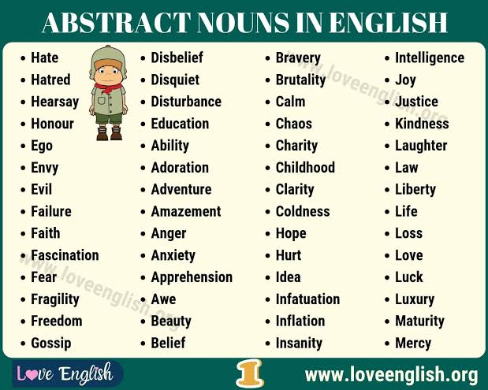
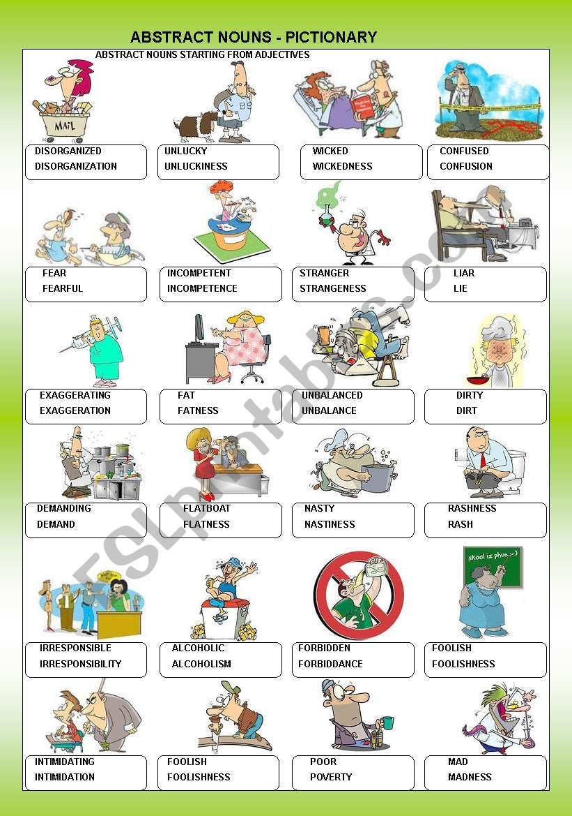
WORKSHEET
- Pick out the abstract nouns in each sentence and write it in the blanks:
Sentences Abstract noun
- Honesty is always respected. : Honesty
- Pride goes before a fall. : Pride
- The child began to jump out of joy. : Joy
- The Taj Mahal is a model of beauty. : Beauty
- Our deeds bring us good or bad rewards. : deeds
- Virtue cannot be bought with money. : Virtue
- Humayun was a model of kindness. : Kindness
- We should never let sorrow overtake us. : sorrow

- Make abstract nouns from the following nouns:
Friend :friendship
Scholar :scholarship
Carpenter :carpentry
Member :membership
Child :childhood
King :kingship

- Make abstract nouns from following adjectives:
Patient : patience false : falsehood
Real : reality deep : depth
Holy : holiness able : ability

- Make abstract nouns from following verbs:
Attract : attractive behave : behaviour
Hate : hatred choose : choice
Know : knowledge educate : education

- Complete the synonym of each given abstract noun:
Gain : Profit Joy : Gaiety
Grief : Sorrow War : Battle
Tallness : Height chum : Friend

- Complete the opposite of each given abstract noun:
Proud : Humble Happiness : Sorrow
Ugliness : Beauty Folly : Wisdom
Stupid : Clever Love : Hatred

